FOSSIL-Vermont-Monkton-Archaeopteris Tree Trunk-380-360 mya

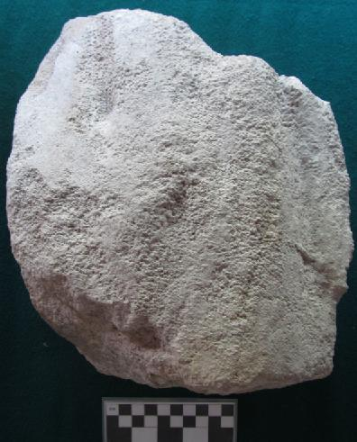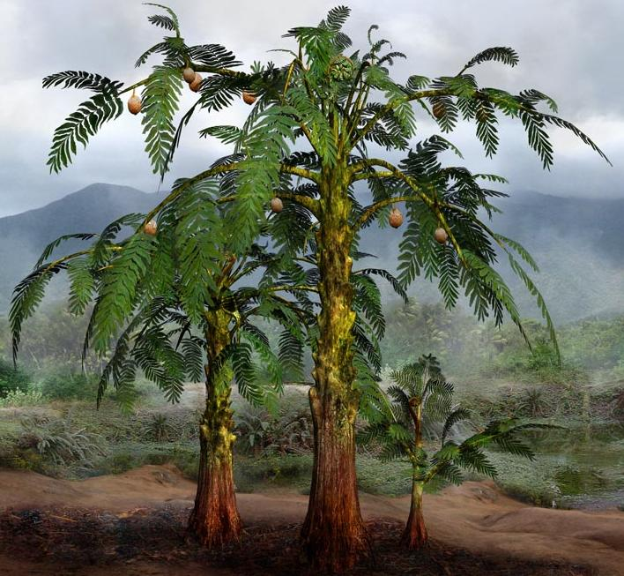
Left: Archaeopteris tree trunk fossil fragment, Monkton, Vermont. Right: Reconstruction of Archaeopteris trees from the Middle Devonian (397 million to 385 million years BP), after http://jfhdigital.com/wp-content/uploads/Alethopteris.jpg.
Case No.: FOSSIL
Accession Number:
Formal Label:
Display Description: This Devonian Age (380-360 million years ago) fossil tree trunk fragment of Archaeopteris is a pro-gymnosperm from which all seed plants evolved. It was found in August 2005 in an abandoned Monkton, Vermont, kaolinite quarry. The specimen of the Archaeopteris trunk presented here with its approximately 17-inch-diameter trunk clearly shows vertical bark ridges that distinguishes it from its cousin the Gilboa tree-fern with its horizontal bark ridges (Stein et al. 2007). Kaolin is an aluminum silicate with the approximate formula 2H₂0Al₂O₃₂SiO₂,
LC Classification:
Date or Time Horizon:
Geographical Area: Monkton, VT
Map:
GPS Coordinates:
Cultural Affiliation:
Medium:
Dimensions:
Weight:
Provenance:
Condition:
Discussion: Archaeopteris trees proliferated in damp forests along the banks of sloughs that were oriented north-south along the Cheshire Formation that extends southward from Lake Champlain along a linear belt on the western side of the Vermont and the eastern side of New York, an area that was the shore of an ancient sea (Taylor and Taylor 1993). The clay mineral kaolinite that constitutes the material of this fossilized trunk is a hydrous aluminum silicate [Al₂(Si₂O₅)(OH)₄] and was quarried at Monkton, Vermont, from the early 1800's until the late 1960's to make white house paint and pottery. However, because Monkton kaolinite contained a high proportion of quartz grains it was not pure enough to use in its natural state so the quartz grains had to be removed by a separation process that by the 1960's became too costly and so the Monkton quarry was abandoned. Other quarries in Bennington and Shaftsbury, Vermont, also mined kaolinite, but they were able to extract the kaolin more cheaply probably because the quartz content was less and so they were able to remain in operation.
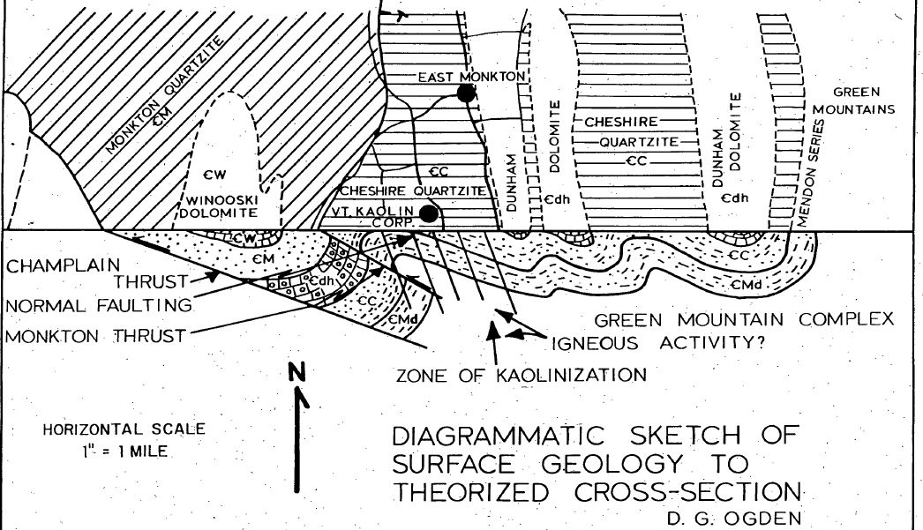
References:

Ogden, Duncan. 1969. Geology and Origin of the Kaolin of East Monkton, Vermont. Vermont Geological Survey. Montpelier Dept. of Water Resources.

Stein, William E., Frank Mannolini, Linda Van Aller Hernick, Ed Landing & Christopher M. Berry. 2007. Giant cladoxylopsid trees resolve the enigma of the Earth's earliest forest stumps at Gilboa, Nature 446, 904-907 (19 April).
Taylor; Thomas N, Edith L Taylor. 1993. The biology and evolution of fossil plants. Englewood Cliffs, N.J. : Prentice Hall.

Van Hoesen, John, 2016, Final report summarizing the surficial geology
and hydrogeology of Monkton, Vermont: Vermont Geological Survey
Open File Report 2016-2

